Monthly inflation report
MONETARY POLICY DEPARTMENT

MAY 2021

Contents
PREFACE ii
THE CONSUMER PRICE INDEX ii
KEY POINTS 4
HEADLINE INFLATION 5
(1)FOOD INFLATION 6
(2) NON FOOD INFLATION 10
CORE INFLATION 15

PREFACE
Based on the article 2 of Da Afghanistan Bank (DAB) law, the primary objective of DAB is to maintain price stability, which is a situation where inflation is low enough that it no longer has a substantial effect on people’s economic decisions.
Generally, the aim of the Monetary Policy Department (MPD) is the price stability and reaps benefit from low inflation in the economy. Besides, MPD is responsible to design and implement sound and prudent monetary policy to contribute to economic growth and strengthen financial stability.
Inflation always refers to an increase in the overall price level, which showed by national currency. Inflation does not refer to an increase in the cost of one product or service or even several products. Prices tend to go up when demand for goods and services exceeds the economy’s capacity to meet the extreme demand of goods and services.
MPD evaluates changes in inflation by monitoring several different price indices. A price index measures changes in the price of a basket of consumer goods and services. They also consider several price indices, because different indices track different products and services, and since indices are calculated differently, therefore, various indexes can send diverse signals about inflation.
It is obvious that an economy cannot have a dynamic and sustainable growth if there are extreme fluctuations in the price level. MPD is committed to feature, adapt and execute a prudent and sound monetary policy in order to maintain inflation in a single digit up to an acceptable level and strengthen its dynamic contribution to the economic growth considering the economic performance of the country and the stability in the country as a whole.

THE CONSUMER PRICE INDEX
The Consumer Price Index (CPI) is a broad measure of cost of living in Afghanistan. However, there are some other methods to measure movements in price level, but still the CPI is accepted and known as the most important indicator due to its widespread use.
The National Statistics and Information Authority (NSIA) have brought some changes in the CPI basket in both base-year (changed to April 2015 from March 2011) and items. As a result, significant changes can be observed in the current weight and index. The CPI basket has changed as some of previous items have excluded and some of them have merged. The new changes to the basket will represent a good picture of inflation trend. For example, in the Food items, beverages now merged with Food main item, tea and beverages, which came under the Food items replaced by non-alcoholic beverages. In the Non-food items, housing item renamed as housing, electricity, water and gas and some of the previous items under housing such as rent, construction materials and fuel have excluded. Meanwhile, in the non-food items some items have been included such as recreation, culture, restaurants, and hotels.
Weight of any item in the basket reflects the percentage that the item has in the total basket and reflects typical consumer spending patterns. For instance, since people usually spend more on food than health, changes in the price of food have a bigger impact on the index than changes in the price of health.

A CONCISE REVIEW OF INFLATION IN AFGHANISTAN
From a long run perspective, the inflationary prospects can only be favorable, controllable and manageable by the central bank if the economic policies, strategies and plans could lead and result to reduction of the gap of production and dependency level of the local markets to imported goods. In addition, regarding the factors of inflation in Afghanistan, currently there are number of factors in the country that play role in unfavorable price movements. The main driver of inflation in Afghanistan is imported inflation from the major trading partners of the country such as Pakistan and Iran. As mentioned above, the country is deeply dependent on importing consuming goods from abroad, thus the inflation of these countries directly affects the inflationary prospects in Afghanistan.
Low level of production in the country, high level of dollarization, non-existence of a proper transportation system inside the country, cross border issues in transportation of goods and services through Pakistan and Iran, imperfect competition, existence of monopoly in the market, political and economic instability, and future uncertainty are the major contributors to the fluctuation in prices in the country. Beside those obstacles, the DAB has successfully maintained the inflation rate in a single digit and the inflation rate is still at a moderate level.

KEY POINTS
- Headline inflation decreasedto 1.35 percent on year over year basis in May 2021 as compared to 6.26 percent in the corresponding month of last year. This decrease is caused by lower prices of food items while non-food items increased during the period.
- Food index which accounts for around 48 percent of the whole CPI decreased to -1.60 percent in May 2021 from12.92 percent observed in the corresponding month of previous year. On the other hand, non-food category which comprises about 52 percent of the overall index increased to 4.60 percent from -0.24percent.
- Core inflation (trimmed mean 30 %) on year over year basis decreased to 2.68 percent in May 2021 from 5.47 percent in the corresponding month of previous year.
- Based on Kabul CPI, headline inflation increased to 5 percent from 3 percent in the month of May, 2021 (Year- over-Year). Food prices exhibited lower rate and non-food items increased in the capital Kabul, food items decreased to 5 percent from 7 percent and non-food category increased to 6 percent from 0.3 percent in the period under review.

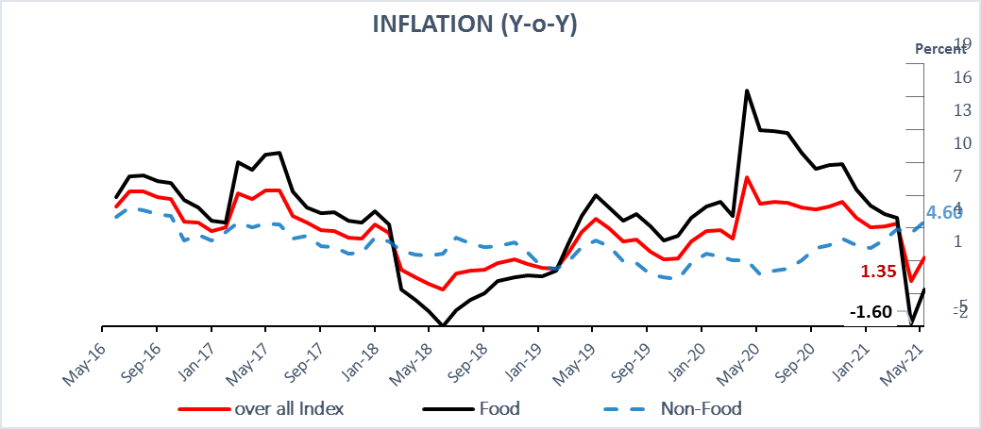

HEADLINE INFLATION
Headline inflation significantly decreased to 1.35 percent in May 2021 as compared to 6.26percent in the corresponding month of last year (year over year). The decreasecaused by lower prices offood items, whilenon-food itemsprices increased during the period.Core inflation (trimmed mean 30 %) on year over year basis decreased to 2.68 percent in May 2021 from 5.47 percent in the corresponding month of previous year.

 | TABLE 1. INFLATION RATE (Y-O-Y) PERCENTAGE CHANGE
 |  |  | Jan 2021 |  | Feb 2021 |  | Mar 2021 |  | Apr 2021 |  | May 2021
National Headline CPI |  | 4.11 |  | 4.13 |  | 4.42 |  | -0.80 |  | 1.35
Food |  | 6.10 |  | 5.32 |  | 4.96 |  | -4.73 |  | -1.6
Non-Food |  | 2.16 |  | 2.95 |  | 3.88 |  | 3.60 |  | 4.60
Kabul Headline CPI |  | 3.41 |  | 3.42 |  | 4.98 |  | -0.39 |  | 5.30
Food |  | 2.62 |  | 1.73 |  | 3.96 |  | -7.36 |  | 4.76
Non-Food |  | 3.95 |  | 4.56 |  | 5.66 |  | 4.94 |  | 5.69

Source: National Statistics and Information Authority (NSIA) / DAB

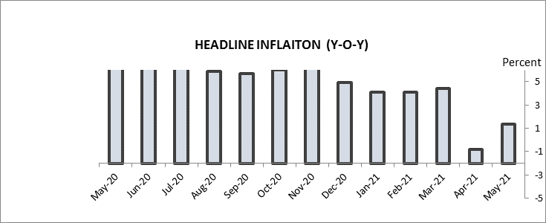

FOOD INFLATION
Food inflation decreased in month of May2021. Food and beverages items are weighted for 47.8 percent of the overall index. When measured year over year basis,food inflation decreased to -1.60 percent in the month of May 2021 from 12.92percent calculated in the corresponding month of previous year. Prices of all food items are decreased in May 2021 compared to same month of previous year.

FOOD AND NON-ALCOHOLIC BEVERAGE
Items | Weight |  | Y-o-Y
 |  | Jan-21 | Feb-21 | Mar-21 | Apr-21 | May-21
Food and Non-Alcoholic Beverages | 47.8 | 6.10 | 5.32 | 4.96 | -4.73 | -1.60
Bread and Cereals | 14.61 | 8.69 | 8.92 | 8.96 | -2.04 | -3.70
Meat | 7.50 | 9.76 | 8.86 | 9.17 | 7.48 | 6.52
Milk, cheese and eggs | 4.70 | 5.95 | 3.33 | 3.51 | 0.69 | -2.78
Oils and fats | 4.58 | 14.87 | 16.16 | 18.78 | 15.87 | 13.72
Fresh and dried fruits | 4.98 | 2.64 | 1.65 | -0.27 | -8.87 | 0.36
Vegetables | 6.01 | -3.73 | -6.78 | -9.69 | -30.91 | -16.55
Sugar and sweets | 2.74 | 5.60 | 6.25 | 7.08 | 3.69 | 3.19
Spices | 1.29 | -5.02 | -6.85 | -9.10 | -21.35 | -14.93
Non-alcoholic beverages | 1.36 | 3.05 | 2.17 | 2.14 | 2.36 | 1.75
Source: National Statistics and Information Authority (NSIA) / DAB

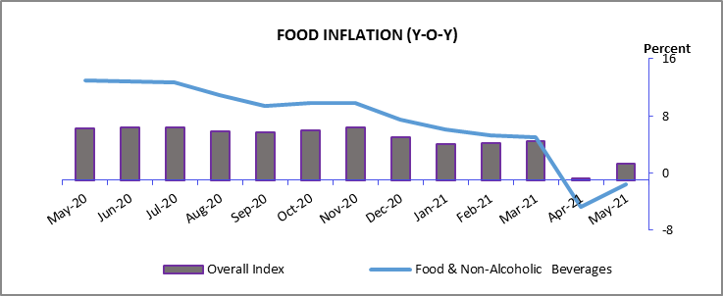

- Bread and cereals price index: This index which accounts about 15 percent of the consumer price index, decreased to -3.70 percent in the month of May2021compared to 14.76percent in the corresponding month of previous year (year over year). Main reason behind decrease in the prices of mentioned index is the ease of restriction and measurement due to Covid-19 pandemic compare to the same month of previous year.

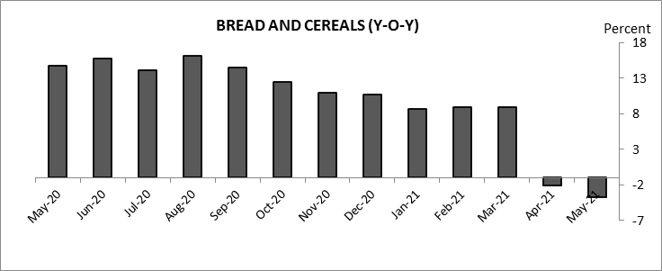

(b) Meat Price index: which is weighted 7.5 percent of the CPI, decreased to 6.52percent in the month of May from 10.70 percent observed in the corresponding month of previous year (year over year).
Increase in number of poultry and fish farms throughout thecountry lead to increased the local supply to the market and also illegal import of chicken from neighboring countries increased, at the same time ease of restriction due to covid-19 pandemic compare to the same month of previous year is considered main reasons behind decreae in the prices of this index.

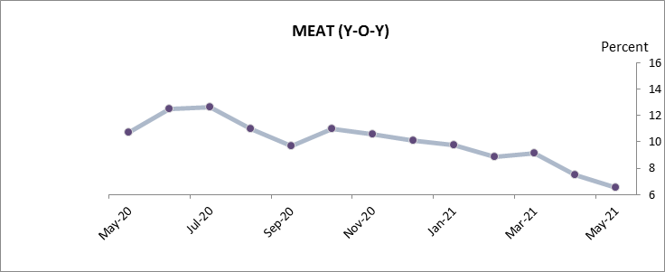

(c) Milk, cheese and eggs price index: This index which comprises 4.7 percent of the overall index showed lower prices during the review period. This index has decreased to -2.78 percent (Y-0-Y) in the month of May from 4.04 percent observed in the same month of previous year.
Reason behind decrease in the prices of this index is the increase in the domestic production of the mentioned index, Afghanistan consume about two billion eggs yearly and 30 percent are produced domestically. Increase in number of poultry and dairly production farms during the year 2021, and ease of city lock down compare to the same month of previous year have decreased the prices of this index during the period.

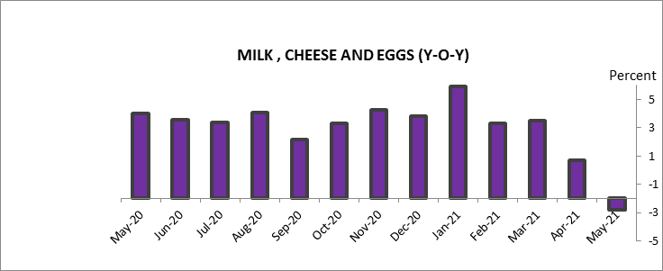

(d) Oils and Fats price index: This index which comprises 4.6 percent of overall index, decreased to 13.72 percent in the month of May2021 from 19.15percent recorded in the same month of previous year.
Increase in the production and domestic supply of sesame and olive oil has decreased the price of this index during the period.
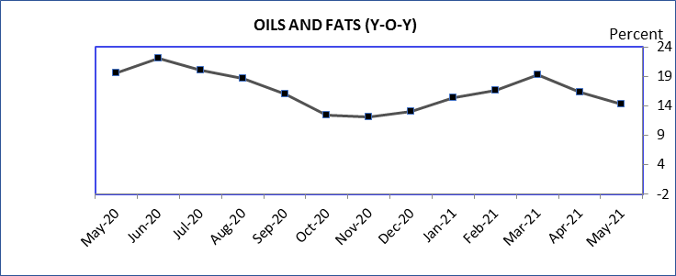

(e) Fresh and dried Fruits index: Observing the data, this index which comprise 5 percent of the whole index decreased to 0.36 percent (year over year) in the month of May 2021 from 10.35 percent recorded at the same month of previous year.Main contribution behind decrease in the price of this index are increase in the production of fruits such as straw berry, fresh figs, citrus and walnut have increased in the country, also during May 2020 price of this index increased mainly due to spread of Covid-19, transport limitation and high demand for fresh fruits contains vitamin C and in current month prices are returned to the normal level.

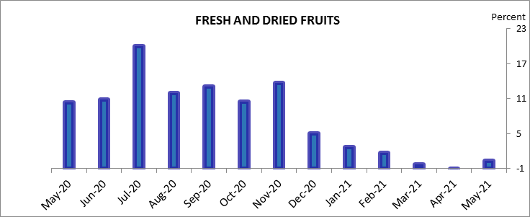
(f) Vegetables price index:which is dedicated for 6 percent of the overall index, decreased to -16.55 percent (year over year) in the month of May 2021 from 23.02 percent observed in the same month of previous year.

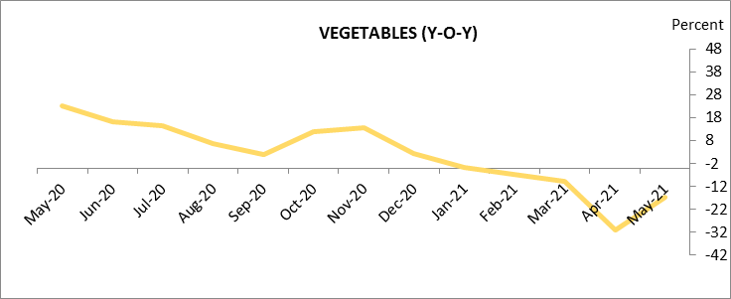

(g) Sugar and sweets price index: This index which comprises around 2.7 percent of the consumer price index decreased to 3.19 percent (year over year) in the month of May 2021 from 3.66 percent recorded in the same month of previous year. However, this change is not likely to affect the CPI dramatically, because it does not make significant weight in the index. honey production in the country especially in the provinces of Khust, Paktia and Ningarhar, Laghman, Badakhshan, Kunduz and Bamyan has increased during the year, which could substitute the sugar to some extent or may lower the consumption of sugar and sweets and caused the price of this index to decrease.

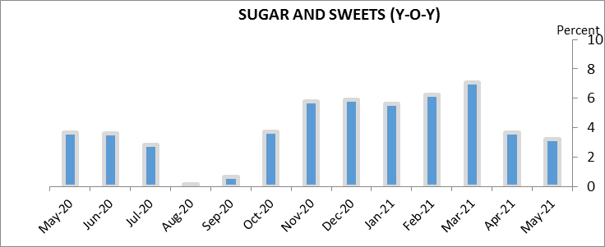

(h) Spicesindex:Observing the data, price of this index decreased to -14.93 percent(Y-o-Y) in May 2021 from 9.59 percentcompare to the same month of previews year.
(i) Non- alcoholic beverages index:Price of this index has decreased to 1.75 percent in May2021 compared to 4.13 percent in the same month of previous year.

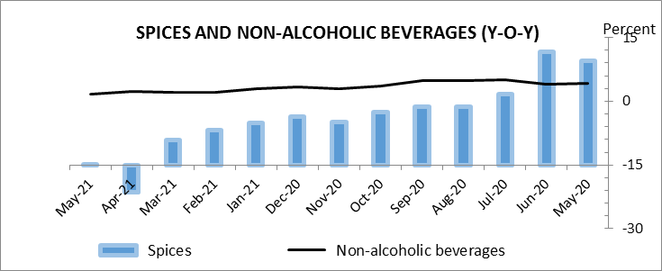

(2) NON FOOD INFLATION
Inflation in non-food items exhibited upward trend in the month of May2021 year on year basis compare to the same month of previews year. On year over year basis, non-food inflation increased to 4.60percent in the month of May2021 from -0.24 percent observed in the same month of previous year. This increase mainly comes from higher prices of tobacco, clothing, housing, furnishing and household goods, transportation, communication, and education.

TABLE 3. NON- FOOD INFLATION
ITEMS | WEIGHT |  | (Y-O-Y) %
 |  | Jan-21 | Feb-21 | Mar-21 | Apr-21 | May-21
Non- Food | 52.2 | 2.16 | 2.95 | 3.88 | 3.60 | 4.60
Tobacco | 0.3 | 4.97 | 5.35 | 5.50 | 4.73 | 4.65
Clothing | 4.6 | 6.93 | 5.51 | 6.16 | 6.72 | 6.01
Housing, electricity, water and gas | 19.1 | -0.28 | 2.16 | 2.51 | 2.53 | 4.78
Furnishing and household goods | 11.9 | 6.08 | 5.40 | 6.62 | 6.13 | 5.40
Health | 6.2 | 6.08 | 5.73 | 5.35 | 4.14 | 3.18
Transportation | 4.3 | -11.81 | -8.34 | -2.42 | -2.07 | 5.08
Communication | 1.7 | -0.66 | -0.68 | 0.76 | 0.54 | 0.38
Information and Culture | 1.1 | 1.30 | 0.58 | 1.90 | 0.78 | 0.78
Education | 0.4 | 5.48 | 5.08 | 5.02 | 6.13 | 6.27
Restaurants and Hotels | 1.1 | -0.14 | -0.39 | 0.30 | -0.06 | 0.18
Miscellaneous | 1.4 | 9.05 | 8.38 | 6.35 | 4.14 | 4.62
Source: National Statistics and Information Authority (NSIA) / DAB

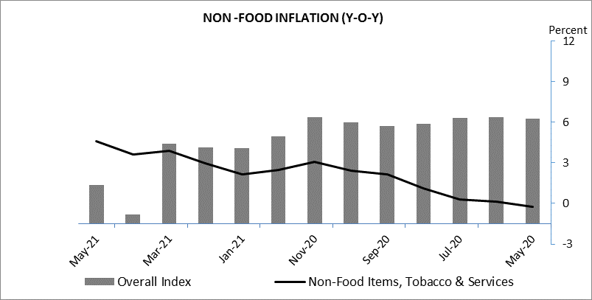
(a)Tobacco price index: which comprises 0.3 percent of the overall index, increased in May2021 to 4.65 from 1.12 (Y-O-Y) recorded in the corresponding month of previous year.

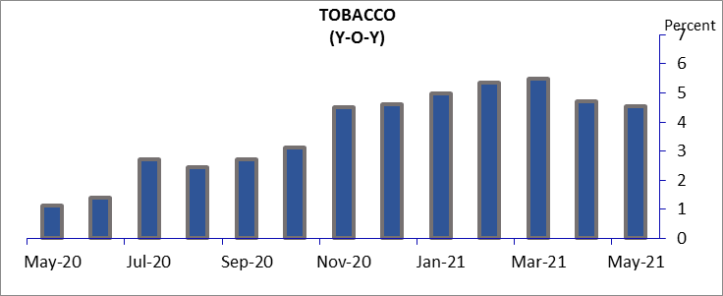

(b) Clothing price index:which comprises around 4.6 percent of the overall index, decreased in May2021 to 6.01 percent (year over year), while it was calculated 10.08 percent in the corresponding month of previous year. Due to covid-19 limitations price of this index increased last year and with the eased of restrictioncompare to the same month of previews year, prices decreased to the normal level.

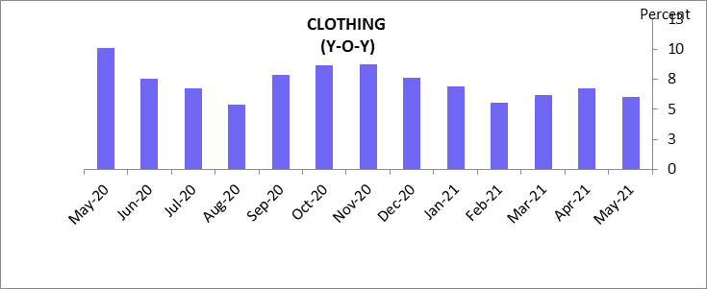

(c) Housing, electricity, water and gas: This index increased to 4.78percent (Y-o-Y) in the month of May 2021 from -4.38 percent observed in the corresponding month of previous year. This index is dedicated for more than 19 percent of the whole index; therefore, any changes in its price may significantly affect the overall CPI. Natural gas prices have increased by 65 percent in international market. Also Brishnasherkat has increased electricity price since past few months which caused increased in price of this index during the period.

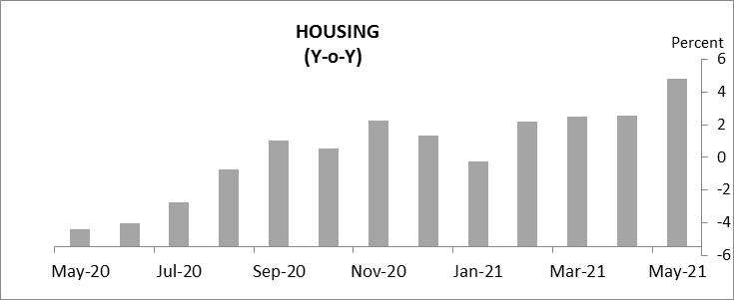

(d) Furnishing and household goods price index: This index which holds a healthy weight of 12 percent in the CPI, increased to 5.40 percent in the month of May 2021 from 1.39 percent recorded in the corresponding month of previous year. Due to covid-19 in last year demand for purchase of this index decreased and during current month prices are returned back to normal level as demand increased for this index.
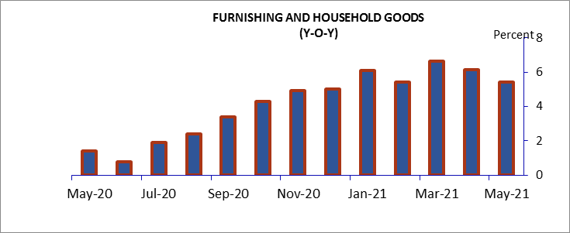

(e) Health price index:Health index which comprises more than 6 percent of the overall CPI, decreased to 3.18 percent (Y-o-Y) in the month of May from 4.36 percent recorded in the same month ofprevious year. Main reason behind decrease in the price of this index is eased of restriction due to covid-19 pandemic compared to the same month of previous year.
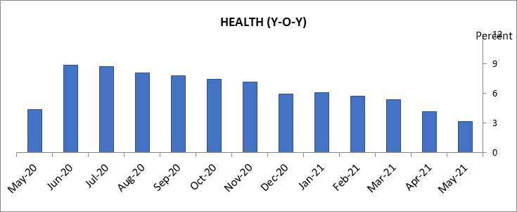

(f) Transportation price index:This index accounts for 4.3 percent of the whole CPI. Observing the data, transportation index increased to 5.08 percent (Y-o-Y) in the month of May from -10.14 percent recorded in the same month of previous year. Reason behind increase in the price of this index is increase of oil prices in international market. Main reason behind increase in the prices of this index is increase in the oil prices in the international markets, during the May 2021 gasoline price are almost doubled in international market.
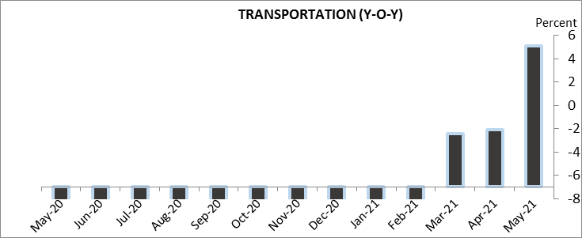

g) Communication price index:The price of this index increasedto 0.38 percent (year over year) from -4.22percent observed in the corresponding month of previous year.

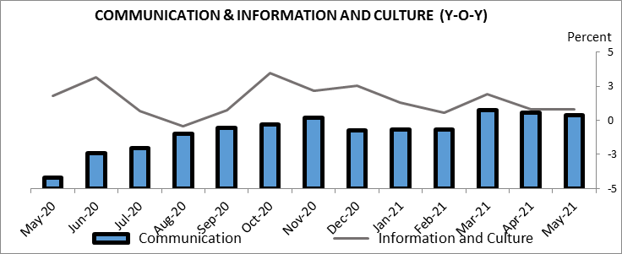

(h) Education price index:This index which comprises 0.4 percent of the overall CPI increased to 6.27 percent (Y-o-Y) in the month of May from1.24 percent recorded in the corresponding month of previous year.In May2020, due to closure of educational centers,education feesdecreased, but in May2021 educational fees returned back to normal level and increased price of this index.

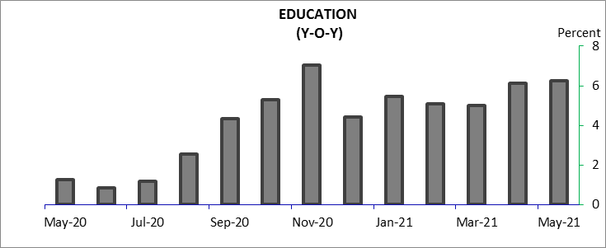

(i)Restaurants and Hotels price index: This index which comprises 1.1 percent of the overall CPI decreased to 0.18 percent in the month of May from 1.76percent recorded in the same month of previous year (year over year).price of all food items decreased during the period which caused decrease in price of this index.
(j) Miscellaneous price index:The price of this index decreased in the month of May to 4.62 percent from 12.40 percent recorded in the same month of previous year (Year-over-Year).
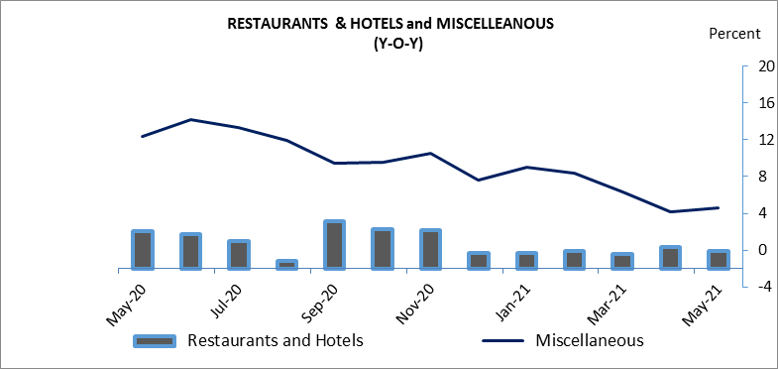

CORE INFLATION
Core measure of inflation gives a more specific view of price changes. This method is used to analyze the inflationary developments cutting off the effects of eccentric factors, which may be seasonal or other specific cases. In this method, those components, which show abnormal changes in their price level, are ignored to put down their effects from the CPI.
One of the most common methods of core inflation is TRIMMED MEAN. This measure is defined for a particular part of the CPI, and is calculated by taking the simple average of the index after excluding the targeted components. During May 2021, trimmed mean (30 % of CPI) increased to 2.68 percent (year over year) from 5.47 percent observed at the same month of previous year.
CPI ex. FOOD & BEVERAGES AND TRANSPORATION increased to 4.56 percent in the month of May 2021 compared to 0.67 percent at same month of previous year.
CPI ex. BREAD AND CEREALS, OILS AND FATS AND TRANSPORATION decreased to 1.45 percent compared to 4.82 percent recorded at same month of previous year.
CPI ex. HOUSING AND TRANSPORATION decreased to 0.50 percent in May 2021, compared to 9.58 percent observed in May, 2020 (year over year).
CPI ex. TRANSPORATION decreased to 1.21 percent in the month of May 2021 compared to 6.98 percent at same month of previous year.
CPI ex. FOOD AND BEVERAGES increased to 4.60 percent in the month of May 2021 compared to -0.24 percent at the same month of previous year.

 | TABLE 4. CORE INFLATION ( Y-O-Y) %
 |  | Jan-2021 | Feb- 2021 | Mar-2021 | Apr-2021 | May-2021
Trimmed Mean |  | 3.98 | 3.61 | 3.78 | 2.26 | 2.68
CPI ex. Food, Beverages & Transportation |  | 3.40 | 3.94 | 3.42 | 4.09 | 4.56
CPI ex. B&C, O&F, and T |  | 3.43 | 3.14 | 3.05 | -1.46 | 1.45
CPI ex. H and T |  | 5.94 | 5.20 | 5.18 | -1.41 | 0.50
CPI ex. Transportation |  | 4.79 | 4.65 | 4.71 | -1.75 | 1.21
CPI ex. Food & Beverages |  | 2.16 | 2.95 | 3.88 | 3.60 | 4.60
