Monthly inflation report
MONETARY POLICY DEPARTMENT

JUNE 2021

Contents
PREFACE ii
THE CONSUMER PRICE INDEX ii
KEY POINTS 4
HEADLINE INFLATION 5
(1)FOOD INFLATION 6
(2) NON FOOD INFLATION 10
CORE INFLATION 14

PREFACE
Based on the article 2 of Da Afghanistan Bank (DAB) law, the primary objective of DAB is to maintain price stability, which is a situation where inflation is low enough that it no longer has a substantial effect on people’s economic decisions.
Generally, the aim of the Monetary Policy Department (MPD) is the price stability and reaps benefit from low inflation in the economy. Besides, MPD is responsible to design and implement sound and prudent monetary policy to contribute to economic growth and strengthen financial stability.
Inflation always refers to an increase in the overall price level, which showed by national currency. Inflation does not refer to an increase in the cost of one product or service or even several products. Prices tend to go up when demand for goods and services exceeds the economy’s capacity to meet the extreme demand of goods and services.
MPD evaluates changes in inflation by monitoring several different price indices. A price index measures changes in the price of a basket of consumer goods and services. They also consider several price indices, because different indices track different products and services, and since indices are calculated differently, therefore, various indexes can send diverse signals about inflation.
It is obvious that an economy cannot have a dynamic and sustainable growth if there are extreme fluctuations in the price level. MPD is committed to feature, adapt and execute a prudent and sound monetary policy in order to maintain inflation in a single digit up to an acceptable level and strengthen its dynamic contribution to the economic growth considering the economic performance of the country and the stability in the country as a whole.

THE CONSUMER PRICE INDEX
The Consumer Price Index (CPI) is a broad measure of cost of living in Afghanistan. However, there are some other methods to measure movements in price level, but still the CPI is accepted and known as the most important indicator due to its widespread use.
The National Statistics and Information Authority (NSIA) have brought some changes in the CPI basket in both base-year (changed to April 2015 from March 2011) and items. As a result, significant changes can be observed in the current weight and index. The CPI basket has changed as some of previous items have excluded and some of them have merged. The new changes to the basket will represent a good picture of inflation trend. For example, in the Food items, beverages now merged with Food main item, tea and beverages, which came under the Food items replaced by non-alcoholic beverages. In the Non-food items, housing item renamed as housing, electricity, water and gas and some of the previous items under housing such as rent, construction materials and fuel have excluded. Meanwhile, in the non-food items some items have been included such as recreation, culture, restaurants, and hotels.
Weight of any item in the basket reflects the percentage that the item has in the total basket and reflects typical consumer spending patterns. For instance, since people usually spend more on food than health, changes in the price of food have a bigger impact on the index than changes in the price of health.

A CONCISE REVIEW OF INFLATION IN AFGHANISTAN
From a long run perspective, the inflationary prospects can only be favorable, controllable and manageable by the central bank if the economic policies, strategies and plans could lead and result to reduction of the gap of production and dependency level of the local markets to imported goods. In addition, regarding the factors of inflation in Afghanistan, currently there are number of factors in the country that play role in unfavorable price movements. The main driver of inflation in Afghanistan is imported inflation from the major trading partners of the country such as Pakistan and Iran. As mentioned above, the country is deeply dependent on importing consuming goods from abroad, thus the inflation of these countries directly affects the inflationary prospects in Afghanistan.
Low level of production in the country, high level of dollarization, non-existence of a proper transportation system inside the country, cross border issues in transportation of goods and services through Pakistan and Iran, imperfect competition, existence of monopoly in the market, political and economic instability, and future uncertainty are the major contributors to the fluctuation in prices in the country. Beside those obstacles, the DAB has successfully maintained the inflation rate in a single digit and the inflation rate is still at a moderate level.

KEY POINTS
- Headline inflation decreased in the month of June 2021 year over year basis. The year over year inflation decreased to 1.56 percent in June from 6.36 percent observed in the previous month. This decrease is caused by lower prices of food items while nonfood items increased during the period.
- Food and beverages items are weighted for 47.8 percent of the overall index. When measure on year over year basis, food inflation decreased to -0.37 percent in the month of June from 12.88 percent calculated in previous month.
- inflation in non-food items exhibited upwards trend in the month of June 2021. On year over year basis, non-food inflation increased to 3.63 percent in the month of June 2021 from 0.13 percent observed in the corresponding month of previous year.
- Core inflation (trimmed mean 30 %) on year over year basis decreased to 2.21 percent in June 2021 from 5.99 percent in the corresponding month of previous year.
- Based on Kabul CPI, headline inflation decreased to 4.36 percent from 4.47 percent in the month of June, 2021 (Year- over-Year). Food prices exhibited lower rate and non-food items increased in the capital Kabul, food items decreased to 5.82 percent from 8.67 percent and non-food category increased to 3.36 percent from 1.74 percent in the period under review.

Figure 1: Inflation (Y-o-Y) _____

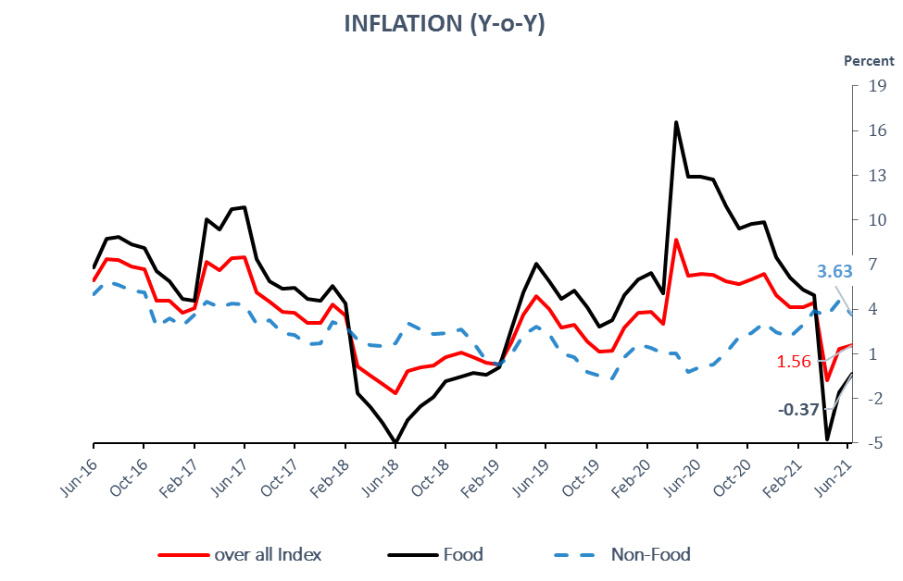
Source: National Statistics and Information Authority/Da Afghanistan Bank

HEADLINE INFLATION
Headline inflation decreased in the month of June 2021 year over year basis. The year over year inflation decreased to 1.56 percent in June from 6.36 percent observed in the previous month. This decrease is caused by lower prices of food items while nonfood items increased during the period.
Core inflation (trimmed mean 30 %) on year over year basis decreased to 2.21 percent in June 2021 from 5.99 percent in the corresponding month of previous year.

 | 21-Jan | 21-Feb | 21-Mar | 21-Apr | 21-May | 21-Jun
National Headline CPI | 4.11 | 4.13 | 4.42 | -0.80 | 1.35 | 1.56
Food | 6.10 | 5.32 | 4.96 | -4.73 | -1.60 | -0.37
Non-Food | 2.16 | 2.95 | 3.88 | 3.60 | 4.60 | 3.63
Kabul CPI | 3.41 | 3.42 | 4.98 | -0.39 | 5.30 | 4.36
Food | 2.62 | 1.73 | 3.96 | -7.36 | 4.76 | 5.82
Non-Food | 3.95 | 4.56 | 5.66 | 4.94 | 5.69 | 3.36

Source: National Statistics and Information Authority (NSIA) / DAB

FOOD INFLATION
decreased in month of June 2021. Food and beverages items are weighted for 47.78 percent of the overall index. When measure on year over year basis, food inflation decreased to -0.37 percent in the month of June from 12.88 percent calculated in previous month. All food items decreased during the period.

Table 2: Food and Non-Alcoholic Beverages (Y-o-Y, in %)

Items | Weight | 21-Jan | 21-Feb | 21-Mar | 21-Apr | 21-May | 21-Jun
Food and Non-Alcoholic Beverages | 47.78 | 6.10 | 5.32 | 4.96 | -4.73 | -1.60 | -0.37
Bread and Cereals | 14.61 | 8.69 | 8.92 | 8.96 | -2.04 | -3.7 | -4.93
Meat | 7.50 | 9.76 | 8.86 | 9.17 | 7.48 | 6.52 | 5.03
Milk, cheese and eggs | 4.70 | 5.95 | 3.33 | 3.51 | 0.69 | -2.78 | -2.42
Oils and fats | 4.58 | 14.87 | 16.16 | 18.78 | 15.87 | 13.72 | 15.8
Fresh and dried fruits | 4.98 | 2.64 | 1.65 | -0.27 | -8.87 | 0.36 | 3.63
Vegetables | 6.01 | -3.73 | -6.78 | -9.69 | -30.91 | -16.55 | -9.68
Sugar and sweets | 2.74 | 5.6 | 6.25 | 7.08 | 3.69 | 3.19 | 2.44
Spices | 1.29 | -5.02 | -6.85 | -9.1 | -21.35 | -14.93 | -12.75
Non-alcoholic beverages | 1.36 | 3.05 | 2.17 | 2.14 | 2.36 | 1.75 | 2.22
Source: National Statistics and Information Authority/Da Afghanistan Bank

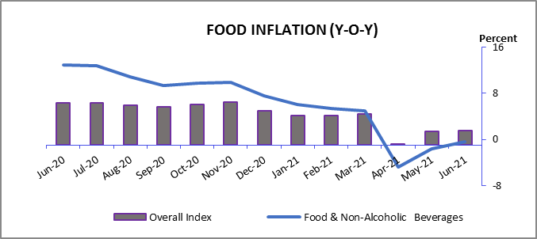

(a) Bread and cereals price index: This index which accounts about 15 percent of the consumer price index, decreased to -4.93percent in the month of June 2021compared to 15.78percent in the corresponding month of previous year (year over year). Main reason behind decrease in the prices of mentioned index is the ease of restriction and measurement due to Covid-19 pandemic compare to the same month of previous year.

(b) Meat Price index: which is weighted 7.50 percent of the CPI, decreased to 5.03percent in the month of June from 12.49 percent observed in the corresponding month of previous year (year over year).
due to covid-19 in same month of last year, cities lock down, measurment and restrictions, number of poultry and fish farms had faced supply chain problems now with the eased of restriction and measurments and establishment of new poultry farms in country especially in province of Faryab, supply to the domestic market has been increased and prices returned to normal level.

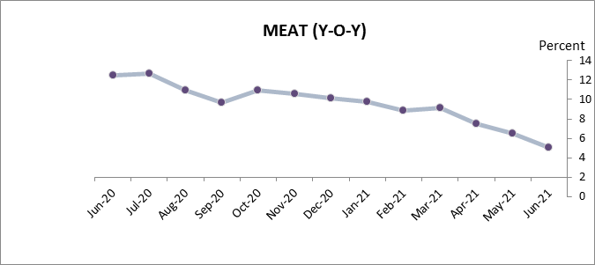

(c) Milk, cheese and eggs price index: This index which comprises 4.70 percent of the overall index showed lower prices during the review period. This index has decreased to -2.42 percent (Y-0-Y) in the month of June from 3.58 percent observed in the same month of previous year.

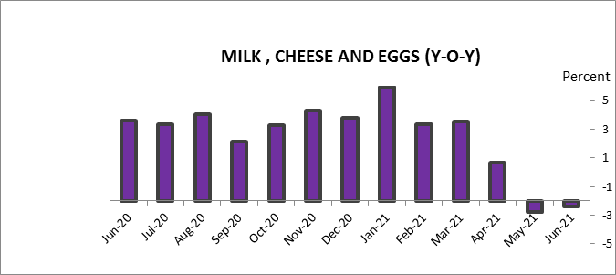

(d) Oils and Fats price index: This index which comprises 4.58 percent of overall index, decreased to 15.80 percent in the month of June 2021from 21.62percent recorded in the same month of previous year.

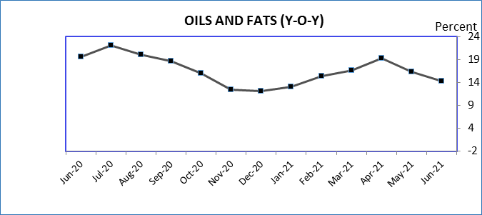

(e) Fresh and dried Fruits index: Observing the data, this index which comprise 4.98 percent of the whole index decreased to 3.63 percent (year over year) in the month of June 2021 from 10.88percent recorded at the same month of previous year.the main reasons behind decrease in the prices of this index are, increase in domestic production, production of fresh fruits increased in country especially production of peach notably increased in kunar province, production of melon and water melon increased in Kunduz, Takhar and Helmand provinces, also production of strawberry increased in Heart province which increased domestic supply during the period.

(f) Vegetables price index:which is dedicated for 6 percent of the overall index, decreased to -9.68 percent (year over year) in the month of June 2021from 16.15 percent observed in the same month of previous year.due to covid-19 and transport limitations price of this index increased during June 2020, in the current month with the ease of restriction price of this index is returned to normal level.

(g) Sugar and sweets price index: This index which comprises around 2.74 percent of the consumer price index decreased to 2.44percent (year over year) in the month of June 2021 from 3.59 percent recorded in the same month of previous year. However, this change is not likely to affect the CPI dramatically, because it does not make significant weight in the index. honey production farms increased in country during the year, especially in Helmand province which could substitute the sugar to some extent or may lower the consumption of sugar and sweets and caused the price of this index to decrease.

(h) Spicesindex:Observing the data, price of this index decreased to -12.75 percent(Y-o-Y) in June 2021from 11.57 percentcompare to the same month of previews year.

(i) Non- alcoholic beverages index:Price of this index has decreased to 2.22 percent in May2021 compared to 4.08 percent in the same month of previous year.
Since sugar is used as one of the raw materials in proccess of non -alcholic beverage production, so an decrease in price of sugar has direct effect on price of this index.

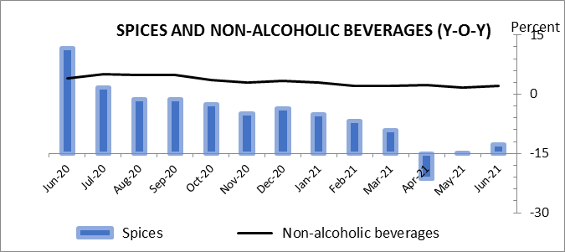

(2) NON FOOD INFLATION
inflation in non-food items exhibited upwards trend in the month of June 2021. On year over year basis, non-food inflation increased to 3.63 percent in the month of June 2021 from 0.13 percent observed in the corresponding month of previous year.This increase comes from higher prices tobacco, housing, furnishing and households,transportation, information and culture, and education.

Table3: Non- Food Inflation (Y-o-Y, in %)

Items | Weight | 21-Jan | 21-Feb | 21-Mar | 21-Apr | 21-May | 21-Jun
 | 52.22 | 2.16 | 2.95 | 3.88 | 3.60 | 4.60 | 3.63
Tobacco | 0.32 | 4.97 | 5.35 | 5.50 | 4.73 | 4.65 | 4.34
Clothing | 4.56 | 6.93 | 5.51 | 6.16 | 6.72 | 6.01 | 6.53
Housing, | 19.10 | -0.28 | 2.16 | 2.51 | 2.53 | 4.78 | 2.99
Furnishing and household goods | 11.93 | 6.08 | 5.40 | 6.62 | 6.13 | 5.40 | 5.96
Health | 6.23 | 6.08 | 5.73 | 5.35 | 4.14 | 3.18 | -0.76
Transportation | 4.32 | -11.81 | -8.34 | -2.42 | -2.07 | 5.08 | 6.51
Communication | 1.69 | -0.66 | -0.68 | 0.76 | 0.54 | 0.38 | -0.03
Information and Culture | 1.14 | 1.30 | 0.58 | 1.90 | 0.78 | 0.78 | -0.18
Education | 0.36 | 5.48 | 5.08 | 5.02 | 6.13 | 6.27 | 5.65
Restaurants and Hotels | 1.13 | -0.14 | -0.39 | 0.30 | -0.06 | 0.18 | 0.36
Miscellaneous | 1.43 | 9.05 | 8.38 | 6.35 | 4.14 | 4.62 | 1.72
Source: National Statistics and Information Authority/Da Afghanistan Bank

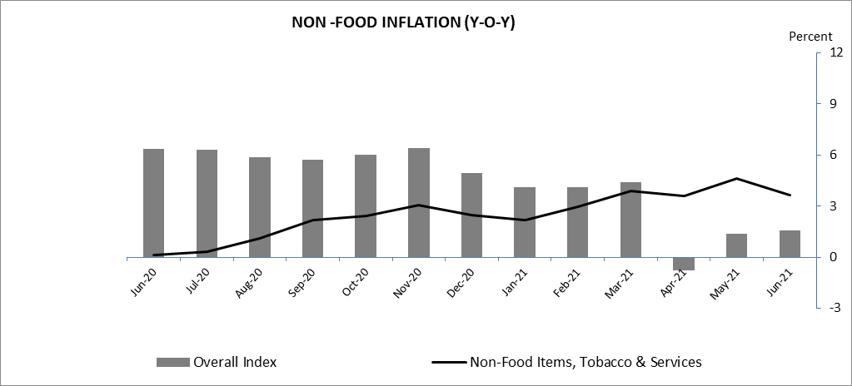

(a)Tobacco price index: which comprises 0.32 percent of the overall index, increased in June 2021 to 4.34 from 1.40 (Y-O-Y) recorded in the corresponding month of previous year.

(b) Clothing price index:which comprises around 4.56percent of the overall index, decreased in June 2021 to 6.53 percent (year over year), while it was calculated 7.54percent in the corresponding month of previous year.
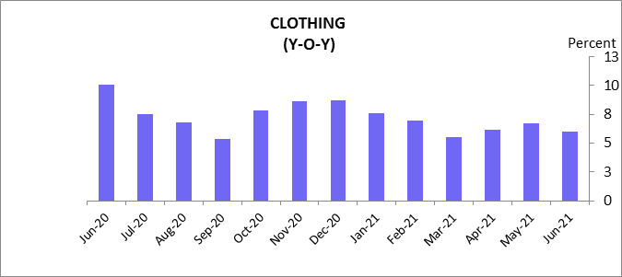

(c) Housing, electricity, water and gas: This index increased to 2.99percent (Y-o-Y) in the month of June 2021 from -4.02 percent observed in the corresponding month of previous year. This index is dedicated for more than 19 percent of the whole index; therefore, any changes in its price may significantly affect the overall CPI. Reason behind increase in the prices of this index is increase in the prices of natural gas in international market, natural gas price increased byalmost 90 percent in international market during one-year period. also Brishnasherkat has increased electricity prices during the period which caused increase in price of this index during the period.

(d) Furnishing and household goods price index: This index which holds a healthy weight of 12 percent in the CPI, increased to 5.96 percent in the month of June 2021from 0.78percent recorded in the corresponding month of previous year. main contribution behind increase of this price index are cotton and wool price in international market increased to 39.60 percent and 46.08 percent respectively.

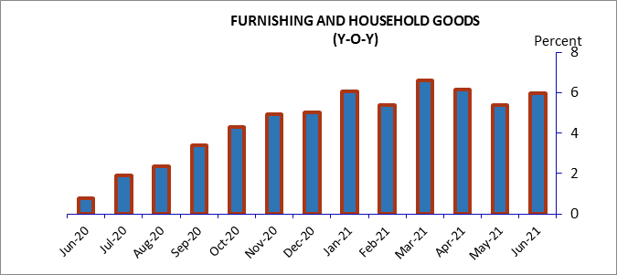

(e) Health price index:Health index which comprises 6.23 percent of the overall CPI, decreased to -0.76 percent (Y-o-Y) in the month of June from 8.86 percent recorded in the same month ofprevious year.reason behind decrease in the price of this index is illegal imports of medicineswhich has increased over the past few months which caused decrease in price of this index during the period.

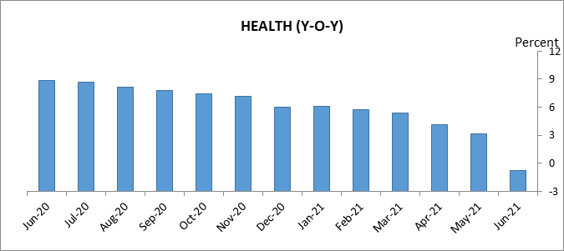

(f) Transportation price index:This index accounts for 4.3 percent of the whole CPI. Observing the data, transportation index increased to 6.51percent (Y-o-Y) in the month of June 2021 from -10.44 percent recorded in the same month of previous year. Reason behind increase in the price of this index is increase of oil prices in international market. Main reason behind increase in the pricesof this index is increase in gasoline and crude oil prices in international market increased by 93 percent and 81 percent respectively during one-year period.

g) Communication price index:The price of this index increasedto -0.03 percent (year over year) from -2.40 percent observed in the corresponding month of previous year.
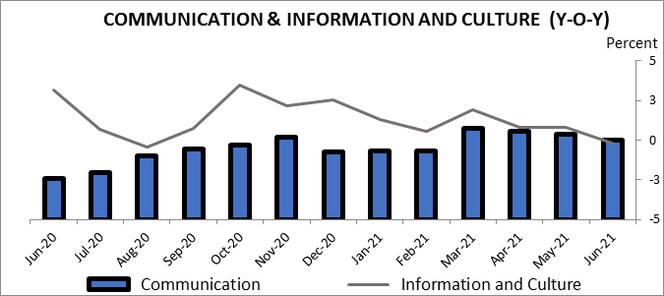

(h) Education price index:This index which comprises 0.36 percent of the overall CPI increased to 5.65percent (Y-o-Y) in the month of June from0.83 percent recorded in the corresponding month of previous year.
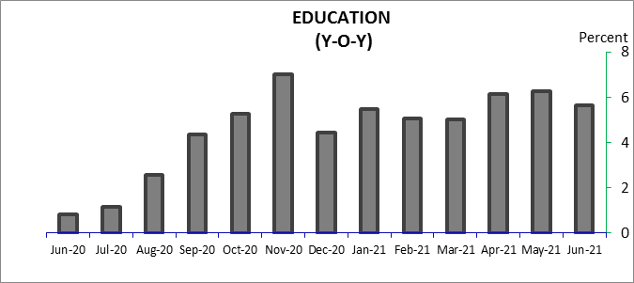

(I)Restaurants and Hotels price index: This index which comprises 1.13 percent of the overall CPI decreased to 0.36 percent in the month of June from 0.97percent recorded in the same month of previous year (year over year).price of all food items decreased during the period which caused decrease in price of this index.
(j) Miscellaneous price index:The price of this index decreased in the month of June 21 to 1.72 percent from 14.17 percent recorded in the same month of previous year (Year-over-Year).

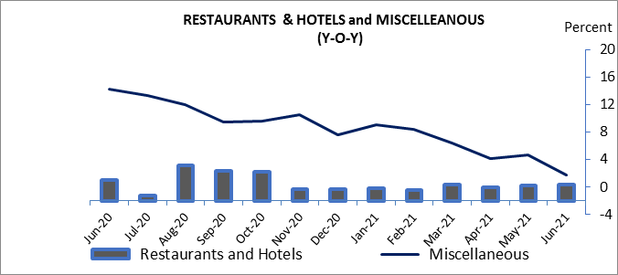

(3) CORE INFLATION
Core measure of inflation gives a more specific view of price changes. This method is used to analyze the inflationary developments cutting off the effects of eccentric factors, which may be seasonal or other specific cases. In this method, those components, which show abnormal changes in their price level, are ignored to put down their effects from the CPI.
One of the most common methods of core inflation is TRIMMED MEAN. This measure is defined for a particular part of the CPI, and is calculated by taking the simple average of the index after excluding the targeted components. During June 2021, trimmed mean (30 % of CPI) decreased to 2.21percent (year over year) from 5.99 percent observed in the previous month.
CPI ex. FOOD & BEVERAGES AND TRANSPORATION increased to 3.40 percent in June 2021 from 1.10 percent compared to same month of previous year.
CPI ex. BREAD AND CEREALS, OILS AND FATS AND TRANSPORATION decreased to 1.78 percent compared to 4.61 percent observed in same month of previous year.
CPI ex. HOUSING AND TRANSPORATION decreased to 1.05 percent in June 2021, compared to 9.68 percent observed in same month of previous year (year over year).
CPI ex. FOOD AND BEVERAGES increased to 3.63 percent in the month of June 2021 compared to 0.13 percent in the corresponding month of previous year (year over year).
CPI ex. TRANSPORATION decreased to 1.37 percent in the month of June 2021 compared to 7.11 percent in the same month of previous year (year over year).

Items | 21-Jan | 21-Feb | 21-Mar | 21-Apr | 21-May | 21-Jun
Trimmed Mean | 3.98 | 3.61 | 3.78 | 2.26 | 2.68 | 2.21
CPI ex. Food, Beverages & Transportation | 3.40 | 3.94 | 4.42 | 4.09 | 4.56 | 3.40
CPI ex. B&C, O&F, and T | 3.43 | 3.14 | 3.05 | -1.46 | 1.45 | 1.78
CPI ex. H and T | 5.94 | 5.20 | 5.18 | -1.41 | 0.50 | 1.05
CPI ex. Food & Beverages | 2.16 | 2.95 | 3.88 | 3.60 | 4.60 | 3.63
CPI ex. Transportation | 4.79 | 4.65 | 4.71 | -0.75 | 1.21 | 1.37

